Assignment 2

Group 1- Robert Chicvak, Laura Delaney, Rajender Katyal, Andy Lawrence

About our project:

The purpose of the website is to advance the knowledge of investors utilizing periodic and real time data. For example, the Tops data will be used to compare the bid verses asking price of a security to identify market anomalies / opportunities.

Data Sources:

Data was added from the Iex Trading APIs. The additional tables added were Market Data / Tops and Stocks / Financial. The application was designed to first select the data from the API. Upon saving, it is persisted to the database.

Responsiveness:

The Financial Application was designed for large screen considering the amount of data included. In the development, a company selection screen was added to easily find the required company. It was consistent with the other functions of the web site selections across the top of the screen.

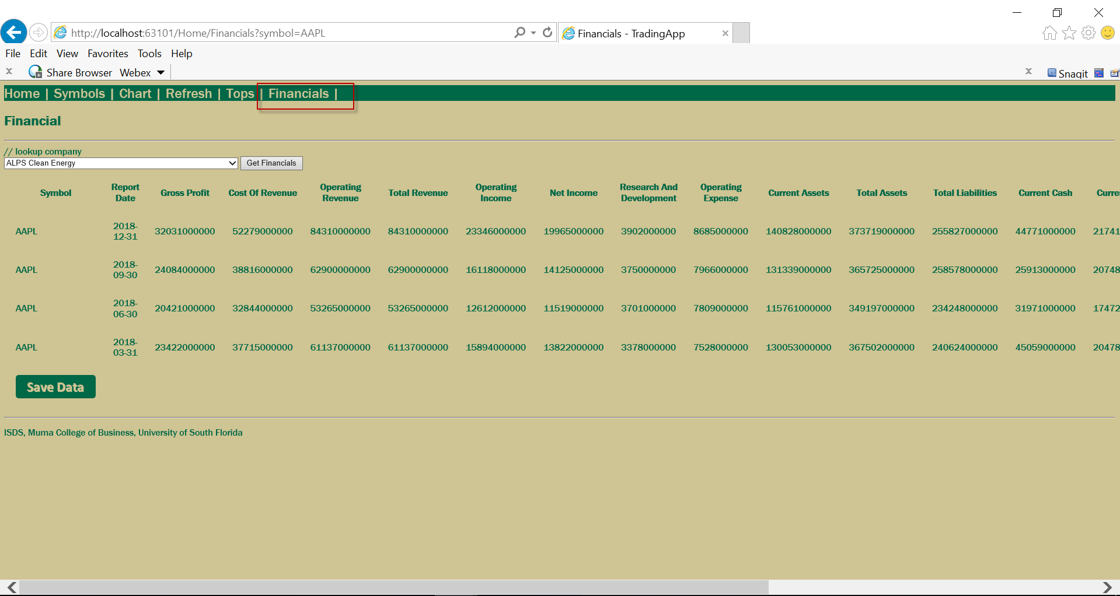

Usability:

The navigation was designed to be streamlined, minimizing the key strokes to obtain the data. There is a lot of data for this requirement and a slider on the bottom is used to see the remaining columns.

Content:

Adding the TOPs (market data) with the Stocks (Financial Data) provides thorough quarterly financial data with the latest bid, ask and sell price to enable buy/sell decisions from the latest quarterly / annual reports. Selections can be added for analysis by sector as well as security type. This is the basis of most financial analysis ratios.

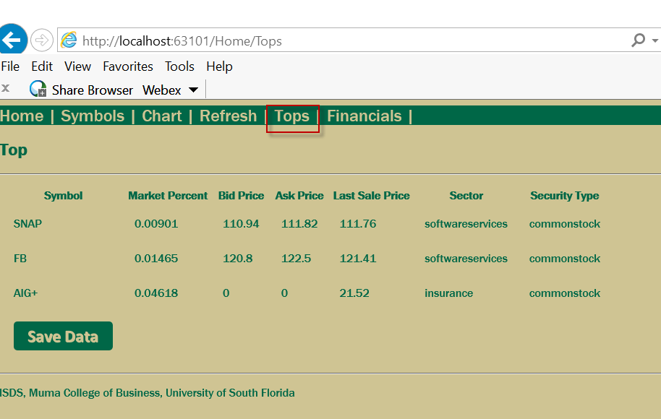

Design:

The logical style was consistent across the pages. The Header remained in place for each menu choice and returned via the home page.

The Physical Style utilized the same font and formatting across the pages for consistency. The Tops and Financials use Bold column headings and normal data fonts. Footer is consistent across all pages

Colors – Consistent colors across all pages with the Gold / Green providing good contrast.

Comments:

This assignment was rewarding for the team to get a glimpse of the options available and to more easily spot a poorly designed web page knowing what is possible. The data was a challenge for us as no team member had any experience with web applications.